Event Capture System (ECS)

Graphical User Interface

Installation Guide

Software Version 2.0

Patch EC*2.0*131



August 2016

Document Version 1.0

**Table of Contents**

1 Introduction 2

1.1 Purpose 2

1.2 Scope 2

2 Installation Requirements 3

2.1 Package Integration 3

2.2 Server Requirements 3

2.3 Client Requirements 3

3 Server Installation 5

3.1 KIDS Installation Example 6

4 Client Installation 8

4.1 RPC Broker 8

4.2 Command Line Parameters 8

4.3 ECS GUI Client Installation 9

4.4 Accessing ECS GUI via CPRS 11

4.4.1 Instructions 12

**List of Figures**

Figure 1 Example: Opening the .zip File. 9

Figure 2 Example: Application File in Folder 10

Figure 3 Example: Desktop Shortcut 10

Figure 4 Example: Adding Server and Port to the Target Field 11

# Introduction

## Purpose

The purpose of this Installation Guide is to provide details on the installation of Event Capture System (ECS) software Graphical User Interface (GUI) for Patch EC*2.0*131. The intended audience includes Technical Services, National Veterans Health Information Systems and Technology Architecture (VistA) Support and Software Quality Assurance.

## Scope

The ECS FY16 Annual Enhancements project specifies enhancements to the current v2.0 Event Capture software application via patch EC*2.0*131 to collect additional information needed for cost and workload management reporting. In order to accomplish this objective, additional data will be added to the current software application to enhance current collection of data and the processes for streamlined data entry and reporting mechanisms. The Managerial Cost Accounting Office (MCAO) has provided a high level list of requested changes or updates to the software for FY16. Examples of the changes include:

* Enhancements to Event Code Screen Management
* Additional Chaplain Procedure Reasons
* Enhanced Reporting capabilities
* State Home Spreadsheet import functionality added
* Enhanced Windows accessibility options compatibility

# Installation Requirements

## Package Integration

The following package versions (or higher) must be installed prior to loading this patch of EC:

Table 1: Required External Packages

| Product Name | Minimum Version |
| --- | --- |
| Current Procedural Terminology (CPT)/Healthcare Common Procedure Coding System (HCPCS) Codes | 6.0 |
| Diagnosis Related Group (DRG) Grouper | 18 |
| Kernel | 8.0 |
| MailMan | 8.0 |
| Patient Care Encounter (PCE) | 1.0 |
| Patient Information Management Service (PIMS) | 5.3 |
| Registration | 5.2 |
| Remote Procedure Call (RPC) Broker | 1.1 |
| ToolKit | 7.3 |
| VA FileMan | 22.0 |

## Server Requirements

Any site not currently running the ECS application and wishing to install ECS GUI must install all previous EC patches. For details on how to install the previous EC patches, please refer to the corresponding patch descriptions and EC 2.0 Installation Guide.

Each user will also need to have the option EC GUI CONTEXT added to their secondary menu.

## Client Requirements

ECS GUI may be run in a test environment before installation, but it is not necessary. EC runs on the standard hardware platforms used by Department of Veterans Affairs (VA) Healthcare facilities.  These systems consist of VMS/Cache or Linux/Cache platforms.

To run this Delphi-based application, the following is recommended:

* Intel Core I3 or higher (I5 recommended)
* Microsoft Windows 7
* Memory: 4GB of RAM or higher
* Hard disk space: 50GB
* VGA or higher resolution monitor
* Mouse or other pointing device
* Networks supported: Any Microsoft Windows 7 or higher compatible network

**Note**: Software that is wholly a local development effort (such as BA Loader, etc.) may not be compatible with Event Capture. Please verify compatibility prior to installation.

# Server Installation

1. Use the INSTALL/CHECK MESSAGE option on the PackMan menu to unload the KIDS distribution included with this message.
2. Select the Installation menu from the Kernel Installation and Distribution System Menu.
3. From this menu, you may elect to use the following options (when prompted for INSTALL NAME, enter EC*2.0*131):
   1. Backup a Transport Global - this option will create a backup message of any routines exported with the patch. It will NOT backup any other changes such as DDs or templates.
   2. Compare Transport Global to Current System - This option will allow you to view all changes that will be made when this patch is installed. It compares all components of this patch (routines, DD's, templates, etc.).
   3. Verify Checksums in Transport Global - This option will allow you to ensure the integrity of the routines that are in the transport global.
   4. Print Transport Global - this option will allow you to view the components of the KIDS build.
4. Use the Install Package(s) option and select the package EC*2.0*131.
5. When the prompt 'Want KIDS to Rebuild Menu Trees Upon Completion of

 Install? NO////' appears, answer YES unless your system does this in a nightly TaskMan process. (NOTE: The new default for this question is NO)

1. When the prompt 'Want KIDS to INHIBIT LOGONs during the install? NO////' appears, answer NO (unless otherwise indicated). (NOTE: The new default for this question is NO)
2. When the prompt 'Want to DISABLE Scheduled Options, Menu Options, and Protocols? YES//' appears, answer YES (unless otherwise indicated).
3. When the prompt 'Enter options you wish to mark as 'Out Of Order':' appears, enter the following options:  EC GUI Context version 2.2.0.0   ... EC GUI CONTEXT
4. When the prompt 'Enter protocols you wish to mark as 'Out Of Order':' appears, press <Enter>.

**Note**: A post-install routine will also run for EC*2.0*131. A routine will automatically run to add and update entries in the PROCEDURE REASON file (#720.4)

## KIDS Installation Example

Select KIDS OPTION: INSTALL PACKAGE(S)

Select INSTALL NAME:    EC*2.0*131    Mar 17, 2016@14:12:37

     => EC*2.0*131

This Distribution was loaded on Mar 17, 2016@14:12:37 with header of

   EC*2*131

   It consisted of the following Install(s):

     EC*2.0*131

Checking Install for Package EC*2.0*131

Install Questions for EC*2.0*131

Incoming Files:

   724      DSS UNIT

Note:  You already have the 'DSS UNIT' File.

Want KIDS to Rebuild Menu Trees Upon Completion of Install? NO//

Want KIDS to INHIBIT LOGONs during the install? NO//

Want to DISABLE Scheduled Options, Menu Options, and Protocols? NO// **YES**

Enter options you wish to mark as 'Out Of Order': EC GUI CONTEXT       EC GUI Context version 2.2.0.0

Enter options you wish to mark as 'Out Of Order':

Enter protocols you wish to mark as 'Out Of Order':

Delay Install (Minutes):  (0-60): 0//

Enter the Device you want to print the Install messages.

You can queue the install by enter a 'Q' at the device prompt.

Enter a '^' to abort the install.

DEVICE: HOME//

 Install Started for EC*2.0*131 :

               Mar 17, 2016@14:12:37

Build Distribution Date: Jan 04, 2016

 Installing Routines:...................

              Mar 17, 2016@14:12:37

 Installing Data Dictionaries: ...

              Mar 17, 2016@14:12:37

 Installing PACKAGE COMPONENTS:

 Installing HELP FRAME......

 Installing SECURITY KEY..

 Installing OPTION..

              Mar 17, 2016@14:12:37

 Running Post-Install Routine: POST^EC2P131

>>>...CHAP COUPLES COUNSELING added to file.

 Updating Routine file...

 Updating KIDS files...

 EC*2.0*131 Installed.

               Mar 17, 2016@14:12:37

 Not a production UCI

 NO Install Message sent

────────────────────────────────────────────────────────────────────────────────

          ┌────────────────────────────────────────────────────────────┐

  100%    │             25             50             75               │

Complete  └────────────────────────────────────────────────────────────┘

Install Completed

# Client Installation

## RPC Broker

The assumption is made that your PC has the required RPC Broker Client Workstation set up. If this is not the case, you should first install this software. The installation is beyond the scope of this Installation Guide, but the RPC Broker files and installation instructions can be found on the VA’s RPC Broker web page. These files must be installed before running the ECS GUI application.

## Command Line Parameters

**Note**: The parameters may be in any order. Parameters S and P are a set, i.e., they must both be present or they will be ignored. If you want Event Capture to take advantage of CCOW Single Sign on, you must add the CCOW parameter to the shortcut. Please note, if you do not have the Vergence desktop program installed, you should not add the CCOW parameter.

Table 2: Command Line Parameters

| Parameter | Example (Default) | Description |
| --- | --- | --- |
| S= | S=BrokerServer | The name of the ECS GUI BrokerServer as defined in the Host file.  The default is ‘BrokerServer’ |
| P= | P=nnnn | The ServerPort used by the ECS GUI BrokerServer.  Example P=9200 |
| CCOW | CCOW | Enable Event Capture to utilize CCOW Single Sign on functionality. |

## ECS GUI Client Installation

Follow these instructions to install the ECS GUI:

***Please note that the installation of the Event Capture GUI software has changed dramatically from previous versions due to the implementation of Security Updates that no longer allow users to install software directly onto their computers. In previous versions, the software was installed via a SETUP.EXE file. In this release, and going forward, the ECS GUI application will be distributed via a .ZIP file containing the actual application file, ECS GUI.EXE. This application file will need to be unzipped/copied to a directory, either network or locally, and a shortcut to that file can be created to run the application. ***

1. Save the EC_2_P131.ZIP file to one of your network or local drives. Do not save it directly to the desktop.
2. Double-click on EC_2_P131.ZIP. The following window will appear.

Figure 1 Example: Opening the .zip File.

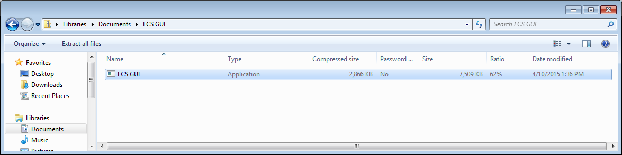

1. Right click the ECS GUI application file and select copy.
2. Choose an existing folder where you want the program installed, or create a new one. (The previous version’s default was C:\Program Files\VISTA\EC). Paste ECS GUI.EXE into your target directory.
3. You should now see the application file in the explorer window for that directory like in this example.

Figure 2 Example: Application File in Folder

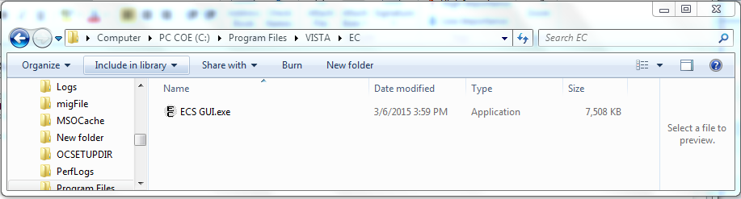

1. Now that the Application file is in the directory, right click on it, and select Send to 🡪 Desktop (create shortcut)
2. A Shortcut should be created on the desktop with the name of ECS GUI – Shortcut (Refer to Figure 3 below).

Figure 3 Example: Desktop Shortcut

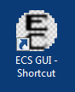

1. Right click on the newly created shortcut and select Properties and navigate to the shortcut tab
2. After the file name (listed in Target), you will need to add the server (example: s=XXXX) and port (example: p=XXXX).

**Note**: Be sure to add one space before you add the server and port information.

**Note**: The server and port can be provided by your particular site. Without this information, Event Capture will not be able to run. If you want to enable Event Capture to use CCOW Single Sign on, add the text CCOW after the port information.

Figure 4 Example: Adding Server and Port to the Target Field

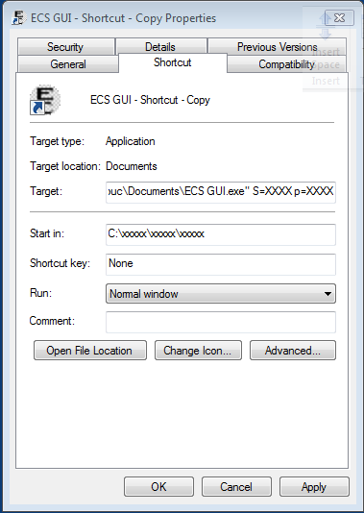

1. Click **Apply.**
2. The setup is complete.

## Accessing ECS GUI via CPRS

A “hot button” that will allow you to switch back and forth between the Computerized Patient Record System (CPRS) and ECS applications can be created in VistA by the site’s Clinical Coordinator. This button can either be created for a specific user or for all CPRS users. This button will be placed in the Tools menu of CPRS GUI so the user will have quick access to it within the application.

### Instructions

**Note**: Parentheses denotes abbreviations that can be entered instead of entering the full name of the option.

1. From the CPRS Configuration Menu for Clinical Coordinators, enter GUI Parameters (GP) at the prompt.
2. From the list of options given, enter GUI Tool Menu Items (TM) at the prompt.
3. From the list of options given, enter Package (9).

**Note:** By choosing this option you are giving this functionality to all users. If you want to give this functionality to one user choose User (1) instead.

1. The user will receive two messages; one regarding the parameters set for ‘Package’ and the other for the Setting of the CPRS GUI Tools Menu for Package.
2. The user will be asked to select a sequence. Type a question mark to get a choice of options.
3. Enter a number higher than the last option to add a new option.
4. When asked if you are adding a new option, enter YES.
5. When prompted for a “Name=Command” enter: Event Capture="c:\program files\vista\ec\ecs gui.exe"
6. When asked to select a sequence again, press <Enter> to get out of prompt.

**Example: Setting Up EC Option in the Tools Menu of CPRS GUI**

AL Allocate OE/RR Security Keys

KK Check for Multiple Keys

DC Edit DC Reasons

GP GUI Parameters ...

GA GUI Access – Tabs,RPL

MI Miscellaneous Parameters

NO Notification Mgmt Menu ...

OC Order Checking Mgmt Menu ...

MM Order Menu Management ...

LI Patient List Mgmt Menu ...

FP Print Formats

PR Print/Report Parameters ...

RE Release/Cancel Delayed Orders

US Unsigned orders search

EX Set Unsigned Orders View on Exit

NA Search orders by Nature or Status

CA Care Management Menu ...

DO Event Delayed Orders Menu ...

LO Lapsed Order search

PM Performance Monitor Report

Select CPRS Configuration (Clin Coord) Option: **GP GUI Parameters**

CS GUI Cover Sheet Display Parameters ...

HS GUI Health Summary Types

TM GUI Tool Menu Items

MP GUI Parameters - Miscellaneous

UC GUI Clear Size & Position Settings for User

RE GUI Report Parameters ...

NV GUI Non-VA Med Statements/Reasons

EX GUI Expired Orders Search Hours

RM GUI Remove Button Enabled

NON GUI Remove Button Enabled for Non-OR Alerts

CLOZ GUI Edit Inpatient Clozapine Message

COAG GUI Anticoagulation Parameters ...

**> Out of order: On hold

EIE GUI Mark Allergy Entered in Error

Select GUI Parameters Option: **TM GUI Tool Menu Items**

CPRS GUI Tools Menu may be set for the following:

1 User USR [choose from NEW PERSON]

2 Location LOC [choose from HOSPITAL LOCATION]

2.5 Service SRV [choose from SERVICE/SECTION]

3 Division DIV [choose from INSTITUTION]

4 System SYS [PERF.ISC-BAYPINES.VA.GOV]

9 Package PKG [ORDER ENTRY/RESULTS REPORTING]

Enter selection: **9 Package ORDER ENTRY/RESULTS REPORTING**

Parameters set for 'Package' may be replaced if ORDER ENTRY/RESULTS REPORTING is installed in this account.

-- Setting CPRS GUI Tools Menu for Package: ORDER ENTRY/RESULTS REPORTING --

Select Sequence: ?

Sequence Value

-------- -----

1 &Time=Clock.exe

2 &Calculator=Calc.exe

3 &Windows Introduction=WinHlp32 Wind

4 &Notepad=Notepad.exe

Select Sequence: **5**

Are you adding 5 as a new Sequence? Yes// **YES**

Sequence: 5// **5**

Name=Command: **&Event Capture="c:\program files\vista\ec\ecs gui.exe"**

For more information on this “tools” option, consult the CPRS user guide at:

<http://www4.va.gov/vdl/application.asp?appid=61>

Previous versions of the EC GUI executable were installed on the user’s workstation at location: C:\Program Files\VISTA\EC (unless another directory was specified on the “Choose Designation Location” screen).

If any prior versions of the applications exists in the user’s directory location referenced above, or if they reside under Applications on the control panel, they should be deleted and uninstalled.

#### Acronyms

| Term | Definition |
| --- | --- |
| CPRS | Computerized Patient Record System |
| CPT | Current Procedural Terminology |
| DD | Data Definitions |
| DRG | Diagnosis Related Group |
| DSS | Decision Support System |
| EC | Event Capture |
| ECS | Event Capture System |
| GP | GUI Parameter |
| GUI | Graphical User Interface |
| HCPCS | Healthcare Common Procedure Coding System |
| KIDS | Kernel Installation & Distribution System |
| MCAO | Managerial Cost Accounting Office |
| PCE | Patient Care Encounter |
| PIMS | Patient Information Management Service |
| TM | Tool Menu |
| VA | Department of Veterans Affairs |
| VistA | Veterans Health Information Systems and Technology Architecture |